Continuous Temperature Volunteer Sampling Methods
Water Action Volunteers Manual
Updated 2025

The Water Action Volunteers (WAV) volunteer stream monitoring program is an ongoing partnership between the University of Wisconsin–Madison Division of Extension, the Wisconsin Department of Natural Resources (WDNR) and nearly 50 local partner groups and organizations. The program aims to preserve, protect and restore Wisconsin’s 86,000+ miles of streams and rivers by educating and empowering volunteers to gather high-quality stream data useful for decision-making and natural resource management, and to share their data and knowledge. Learn more at www.wateractionvolunteers.org.
Questions? Contact Water Action Volunteers staff at wav@extension.wisc.edu.

Why Continuously Monitor Water Temperature?
Changes in temperature can affect all life in the water. For example, warm water doesn’t hold as much oxygen as cold water and can cause plants to grow faster and use more oxygen. While most aquatic animals can survive in a range of temperatures, some, like trout, need cooler water. Warmer water also makes animals use more energy, which means they need more oxygen. Studies show that big temperature changes can make fish and insects more likely to get diseases or suffer from toxins and parasites.
Collecting continuous water temperature data on all sizes (small, medium, and large) and types (warm, cool, cold) of streams is incredibly useful when making management decisions. Your continuous temperature data can be used to:
- Document baseline water temperatures.
- Determine if a stream is a cold, cool, or warm water stream.
- Aid in documenting and determining the effects of thermal discharges on aquatic life.
- Aid in location of groundwater influence to streams.
- Document storm-water effects on streams.
- Document temperature impacts of structural dams and beaver dams to cold water streams.
- Distinguish brown trout streams from potential native brook trout streams.
- Document changes in stream temperatures after installation of agricultural and urban best management practices.
- Aid in development of a model that uses landscape factors to predict stream temperatures.
- Assess the impact of climate change.

Temperature ranges for cold, cool, and warm water stream are the following:
- Cold= maximum summer daily mean temperature <22 C (<72 F)
- Cool = maximum summer daily mean temperature 22 to 25 C (72 to 77 F)
- Warm= maximum summer daily mean temperature >25 C (>77 F)

Thermistor Background Information
Thermistors are continuous temperature monitoring devices. They record and store water temperature for long periods of time. For WAV stream monitoring, our thermistors record the water temperature every hour from May to October. Thermistors are launched (programmed for the date and time to start recording temperature) by WAV staff and then distributed to volunteers. Volunteers deploy (install) the thermistors at designated sites across the state. During the sample season, volunteers check on thermistors monthly to ensure they are still present, submerged, and free from silt or vegetation cover. At the end of the sample season, volunteers retrieve thermistors from the stream and return them to WAV staff to download the stored data.

Volunteer Time Commitment
We estimate time commitment per volunteer to be 1.5 to 2 hours per year. This does not include travel time to/from their monitoring site, nor does it include time for the volunteer to mail the thermistor back to WAV staff at the end of the season.
Installation and removal time takes approximately 30 minutes per site, and volunteers are expected to check on thermistors at least once per month, which we estimate takes 10 minutes per site per visit.
Volunteers must commit to thermistor monitoring for the entire sample season. If a volunteer is unable to check the thermistor each month, they should alert WAV staff in order to arrange an alternative person to check the thermistor.

Required Equipment
UW Extension and DNR provide:
- One thermistor per monitoring site, shipped to the volunteer in April
- One PVC protective case
- Cost of shipping to send thermistor to volunteer
- One copy of the thermistor log sheet per monitoring site per year

Volunteer provides:
- Mechanism for installing thermistor in stream
  - Rebar method:
    - Rebar
    - Rubber mallet, to pound rebar
    - 4-6 zip ties, depending on thermistor model
  - Cinder block method:
    - Cinder block
    - Heavy-gauge, bendable wire – enough to wrap tightly around the cinder block 3 times. We recommend 9 gauge wire.
    - Wire cutters
    - 4-6 zip ties, depending on thermistor model
- Transportation to and from the monitoring site
- Cost of shipping the thermistor back at the end of the season

Training
Volunteers are expected to read this manual in its entirety. If hands-on assistance is needed for volunteers to learn how to deploy, check on, and remove their thermistors, please contact WAV staff, and they can arrange in-person assistance from local professional staff.

Thermistor Placement in the Stream
In a shallow stream, or streams prone to low water, place the thermistor close to the bottom of the stream. This is to ensure the thermistor stays submerged the entire season. This placement will require checking the thermistor more often to ensure silt has not built up over the thermistor, and that the thermistor is still submerged.
In a deeper stream or in streams less prone to water fluctuation, thermistors can be placed halfway between the bottom of the stream and surface of the water.
Here are rules of thumb to follow as you are selecting where to install your thermistor:
- Thermistors should be deployed in an area of the stream that is flowing freely and well-mixed. Choose a part of the stream that is best representative of the average water depth, i.e. do not place in deep pools, shallow riffles, etc. Do not place thermistors in stagnant or isolated pools, back eddies, wetlands, thick stands of vegetation such as cattails, or beaver ponds.
- Do not place thermistors immediately downstream of a tributary confluence (where two streams meet), impoundment or dam, effluent or stormwater discharge pipe. In these places, the water temperature will be temporarily different compared to the rest of the stream reach and will not represent the typical conditions.
- The thermistor needs to stay submerged for the entire 6 months it’s deployed, so volunteers should consider areas of the stream less affected by low water levels.
- Volunteers should do their best to minimize direct sun exposure to the thermistors. Use the banks or overhanging vegetation to provide shade.
- Be sure to consider the safety of others using the stream. Do not put thermistors where others are likely to find them, or run into their deployment reinforcements (rebar, cinder blocks, etc. as detailed further in this document). Sometimes there are instances of theft or vandalism. Please help us minimize this by hiding your thermistor the best you can.

Deploying the Thermistor
When deploying your thermistor, please remember that the main goals are to:
- Keep the thermistor submerged for the whole season
- Avoid having the thermistor get buried by sediment or debris
- Secure it well enough so that it will not be lost during the monitoring season (keep in mind the flow of your stream can increase drastically after heavy rain events)

You will be mailed a thermistor prior to May 1. Please deploy the thermistor as soon as possible once you receive it. If you are new to the program, or do not already have one, you will also be mailed a short segment of PVC tubing with holes in it to use to protect the thermistor within the stream.
You can attach your thermistor within the PVC protective case in several ways. You can use heavy gauge wire, twisted multiple times for safety, or several zip ties.
We recommend between choosing 1 of 2 ways to keep the thermistor in the stream:
- Rebar: Better suited for soft-bottom streams. You can use rebar in a rocky-bottom stream, but it may be more difficult to pound into the stream bed.
  - Pound the rebar into the streambed with a rubber mallet, or a post pounder if you have one. Angling the rebar with the flow of water (i.e. the top end of the rebar angled downstream), helps to minimize debris accumulation. If your monitoring location is very silty, you may need to use a longer piece of rebar.
  - Tether the thermistor (encased on PVC protective case) with several zip ties (at least two), or heavy gauge wire (at least two lengths).
- Cinder block: Better suited for rocky-bottom streams. A cinder block will sink in soft-bottom streams, so please do not use cinder blocks in soft-bottom streams.
  - Tether the thermistor (encased on PVC protective case) to the block using heavy gauge wire. Tether from at least two points from the PVC case.
Thermistors cost well over $100 each, and thermistor monitoring is a very in-demand type of volunteer monitoring. Please make every effort possible to ensure your thermistor is well-secured and does not wash away.
Take an accurate GPS reading, a few photos, and make detailed notes about where you place the thermistor in the stream so that you can find it again. Record this information, along with the device serial number, date, and time you placed the thermistor in the stream on your thermistor log. Please send photos of your installed thermistor to wav@extension.wisc.edu.

Checking on the thermistor
Check the thermistor at least once per month to make sure it is present, submerged, and not buried in silt or vegetation. If the thermistor is missing, please continue to look for the thermistor and alert WAV staff. If the thermistor is out of the water, move it to deeper water, and record that you did so on your thermistor log. If your thermistor is buried in silt or vegetation, please clear the debris, and mark this on your thermistor log. If your thermistor is present, submerged, and free from debris, please also mark this on your thermistor log.
Temperature data cannot be used for research and management purposes if the thermistor is sent back at the end of the season without a thermistor log.

What type of thermistor do I have?
The WAV program distributes three types of thermistors to volunteers. Each device performs the same action. However, because margins of errors differ between devices, it is important to note your device type on your thermistor log. Holes on the thermistors are locations to use for zip ties or wire.

Tidbit V2 | U22-001 | MX Temp 400
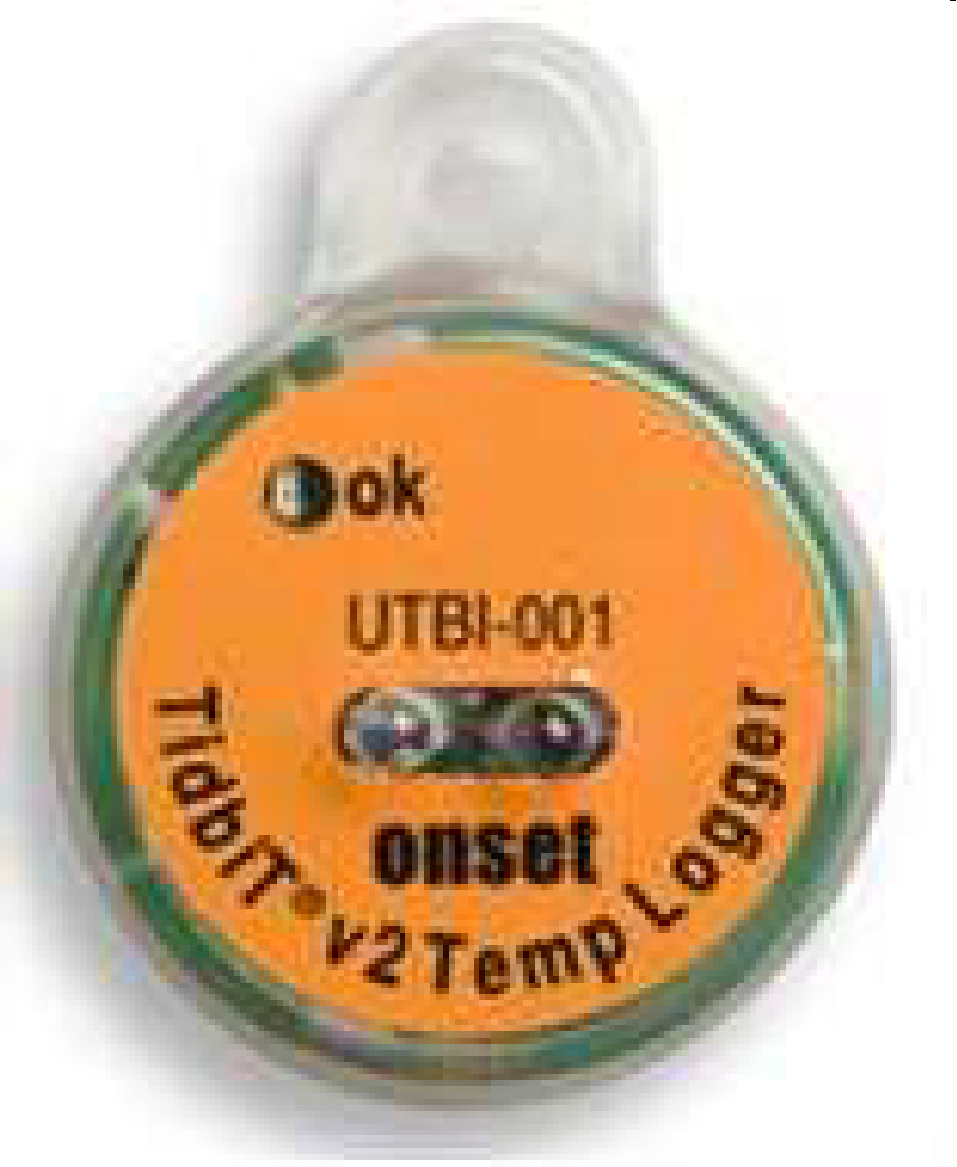 | 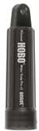 | 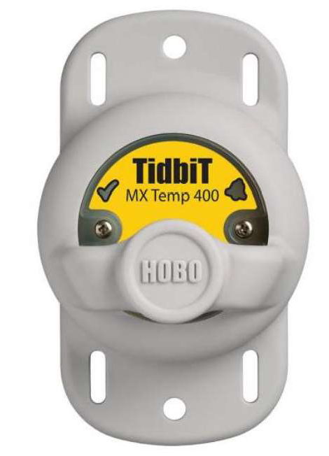

Retrieving the thermistor
As late as you can in October, pull up the rebar or cinder block to which the thermistor is attached. Note the date and time of retrieval on your thermistor log. Clean and dry your thermistor. This may require some scrubbing, as some thermistors become coated with algae. Mail your thermistor back to WAV using the address provided to you from WAV staff via email. PVC cases do not need to be returned each year if you plan to participate in thermistor monitoring the following year.

Thermistor Logs
Once launched, the thermistors begin to constantly log temperature data at one-hour intervals. When the data are downloaded, we need to delete all readings from when the thermistor was not in the water (pre and post deployment, as well as any low water events that left the thermistor suspended above the water). Carefully and completely filled out Thermistor Logs are essential for determining what data to cut out. Thank you for taking the time to fill them out throughout the season and return them with your thermistor at the end of the monitoring season! Please mail them back with your thermistor at the end of the season.

Safety
Some sites may be located in remote areas with limited cellular reception while others are located in more urban areas. Inclement weather such as rain and wind are possible. During monitoring, there may be slippery and uneven surfaces. You are encouraged to wear supportive footwear and to avoid concrete boat ramps and steep banks. When entering the water, caution should be used to avoid slippery surfaces, steep banks, and areas of strong currents. You are encouraged to wear a life jacket. Collecting samples in extremely hot and humid weather carries the risk of dehydration and heat stroke.
Do not place thermistors in areas heavily used for fishing or swimming, and avoid cattle crossings.

Data Integrity and Volunteer Responsibility
Stream temperature data may not be used if volunteers fail to comply with the procedures outlined in this document. A volunteer’s participation in the program will rely on consistent sampling that follows protocol. WAV staff have the right to decide if a volunteer will not continue with the program due to failure to comply, if applicable.

Appendix: Photos of thermistor installation

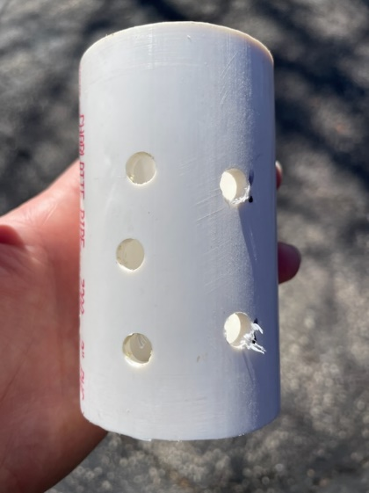
Figure 1 PVC housing for thermistors
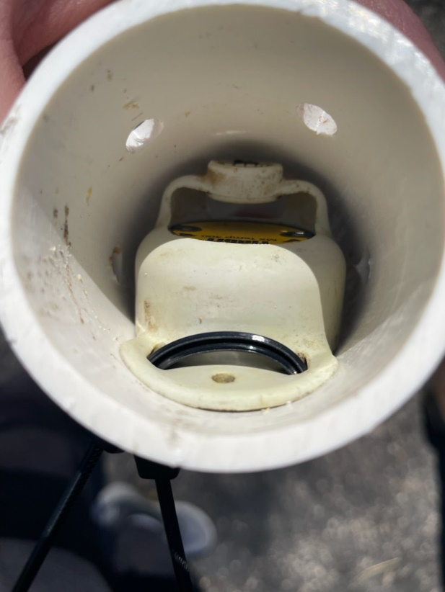
Figure 2 MX400 thermistor in PVC housing
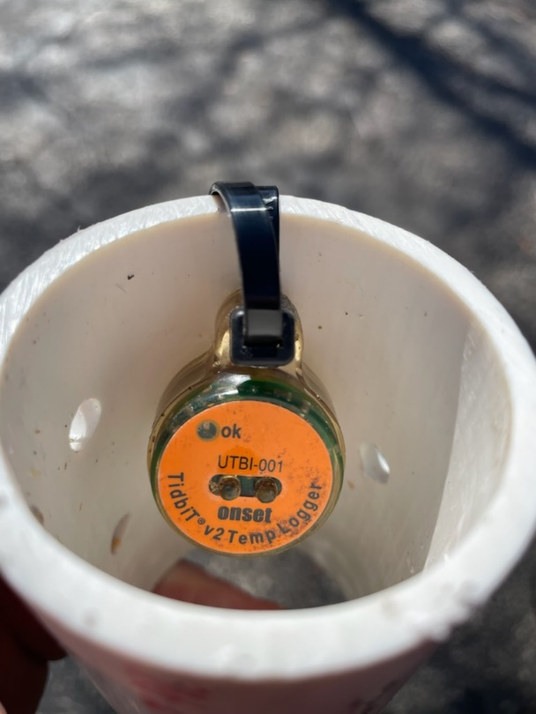
Figure 3 Tidbit V2 thermistor in PVC housing
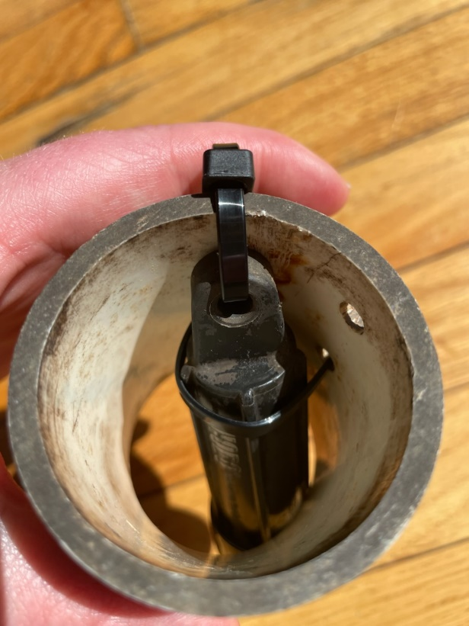
Figure 4 U22 thermistor in PVC housing

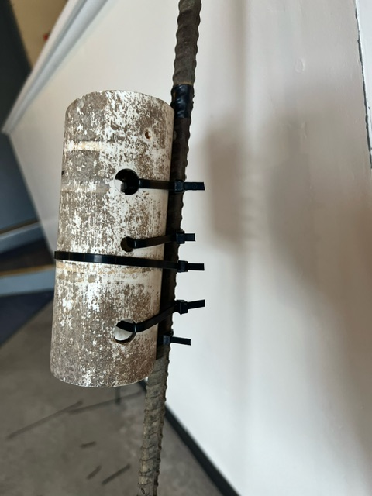
Figure 5 PVC housing with thermistor inside zip tied to rebar (Photo credit: Gary Hermann)
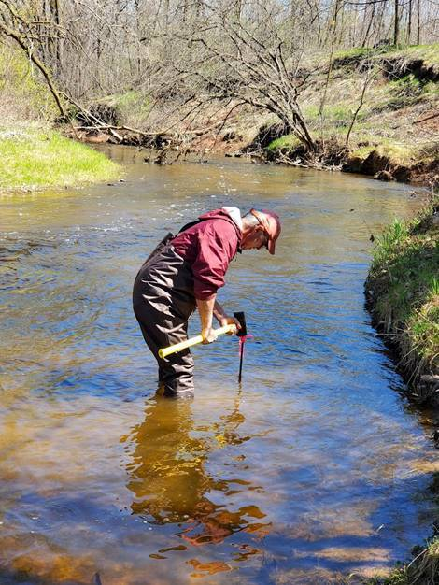
Figure 6 Volunteer installing rebar with thermistor into stream (Photo credit: Laura DeGolier)

