
Purchasing Guide for the WAV Baseline Stream Monitoring Kit
Updated: January 2026
Questions or suggestions? Contact us at wav@extension.wisc.edu.
Quick tips:
- Many items have a cheaper cost per unit if they are bought in bulk.
- Some of larger or specialty items may be temporarily out of stock or have price fluctuations and discounts at different times of year.
- Organizations with a larger budget may invest in a multi-parameter handheld optical meter, such as those sold by YSI or Hanna.
Parameter | Item | Cost per unit | Example suppliers
Water temperature | Thermometer  - Units in Celsius  - 1 degree increments or finer  - Metal/plastic case to prevent glass breaking in the stream | $10 - $32 | Forestry Suppliers (#77141)  Cabela’s (#36126000)
Transparency | Transparency (Turbidity) Tube  - 120cm length | $65 - $118 | Forestry Suppliers (#531557)  School Specialty (#77292)
Dissolved oxygen | Hach Dissolved Oxygen Test Kit Model OX-2P  - Kit comes with chemicals for 100 tests  - Does not come with Starch indicator solution | $151 | Hach (#146900)
Dissolved oxygen | Starch Indicator Solution  - 1 liter bulk bottle. Purchase small plastic dropper bottles to distribute across multiple Hach kits. | $32 | Hach (#34953)
Dissolved oxygen | Safety Glasses or Goggles | $1.27 | Many options – prices vary
Streamflow | Measuring Tape Reel | $18 - $26 | Forestry Suppliers (#39968)  Grainger (#3LJU4)
Streamflow | Calculator (or use phone) | $0 - $3 | Many options – prices vary
Streamflow | Stopwatch (or use phone) | $0 - $3 | Many options – prices vary
Streamflow | Tennis ball | $0.35 | Many options – prices vary
Streamflow | Wire Marking Flags | $0.13 | Many options – prices vary
Streamflow and Biotic Index | D-frame Aquatic Net  - Minimum 500 micron mesh to trap small bugs  - Wood or aluminum handle. Write depth measurements (10ths of feet) on the handle with a sharpie. | $124 - $206 | Forestry Suppliers (#53770, #53788)  Fisher Scientific (#S85027)
Biotic Index | White Basin and Ice Cube Tray | $3.00 | Many options – prices vary
Biotic Index | Handheld Magnifying Glass | $1.75 | Forestry Suppliers (#61233)
Biotic Index | Plastic Spoons, Pipettes, and Tweezers | $2.00 | Many options – prices vary
General | Backpack  - A 17 inch size or larger will hold all kit items.  - Recommend a clear plastic backpack | $6 - $20 | Many options – prices vary
General | Boot brush  - Horse hoof picks are used to clean boots and waders to prevent the spread of aquatic invasive species. | Free | Contact WAV staff
Total Kit | Does not include taxes or shipping | $415 - $600

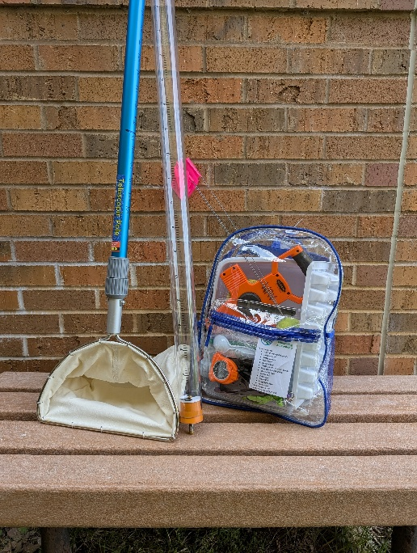
Water quality monitoring suppliers include but are not limited to:
- Fisher Scientific
- Fondriest Environmental
- Forestry Suppliers
- Grainger
- Hach Company
- School Specialty
- Ward’s Science

