Total Phosphorus Volunteer Sampling Methods
Water Action Volunteers Manual¹

Table of Contents
- Project Contacts 1
- Project Background and Goal 2
- Volunteer Time Commitment and Duties 3
- Safety 4
- Field Sampling and Preservation Methods 4
- Delivery of Samples to the Wisconsin State Lab of Hygiene 9
- Field Quality Control: Duplicate Samples 12
- Equipment Cleaning Procedures 14

Project Contacts
The Water Action Volunteers (WAV) volunteer stream monitoring program is an ongoing partnership between the University of Wisconsin–Madison Division of Extension, the Wisconsin Department of Natural Resources (WDNR) and nearly 50 local partner groups and organizations. The program aims to preserve, protect and restore Wisconsin’s 86,000+ miles of streams and rivers by educating and empowering volunteers to gather high-quality stream data useful for decision-making and natural resource management, and to share their data and knowledge. Learn more at www.wateractionvolunteers.org.
Questions? Contact Water Action Volunteers staff at wav@extension.wisc.edu.

Last updated 2025

This manual is written for people participating in Wisconsin Department of Natural Resources (DNR)-funded nutrient data collection with the Water Action Volunteers program. If your project has external funding, please consult with WAV staff to learn how your sampling process may be different.

Why monitor for phosphorus?
Phosphorus is an essential nutrient for plants and animals, and also the most visible, widespread water pollutant in Wisconsin. High levels of phosphorus in our lakes and rivers can trigger excess algae and plant growth, leading to dramatic daily swings in oxygen concentrations. These swings can stress aquatic life, and in extreme conditions, lead to fish kills, and cause other significant problems.
Phosphorus is associated with excess sediments covering stream bottoms, the most common biological impairment in streams. On a geological time frame, phosphorus in streams and lakes originates naturally from rocks, but its major sources today are usually associated with human activities: soil erosion, human and animal wastes, septic systems, detergents, and runoff from farmland or lawns.
An analysis of phosphorus often includes both total phosphorus and soluble reactive phosphorus. Volunteers will only sample total phosphorus, which is considered a better indicator of nutrient status because its levels remain more stable than soluble reactive phosphorus.
- Total phosphorus includes both particulate phosphorus—which is attached to bottom sediments and contained in plant and animal fragments suspended in water—and soluble reactive phosphorus.
- Soluble reactive phosphorus dissolves in water and readily aids plant growth, but its concentration varies widely over short time periods as plants take it up and release it.

Project Goals and Use of the Data
The goal of WAV nutrient monitoring is to characterize the total phosphorus concentrations most commonly occurring in the streams during the primary algae and aquatic plant “growing season” of May through October.
Total phosphorus data are used by a wide range of programs to evaluate stream health impairments. All data collected through this project will be available in the Wisconsin DNR’s SWIMS surface water database. Interested data users may include Wisconsin DNR staff assessing for U.S. Clean Water Act reports or Total Daily Maximum Load determinations, regional DNR staff conducting watershed planning and reporting, or other public or private entities assessing watersheds.

Volunteer Time Commitment
We estimate the time commitment per volunteer to be approximately 6 to 8 hours per year (including travel time to/from their monitoring site) per monitoring site. Once at the monitoring site, sample collection takes about 5 minutes.

Training
Volunteers must commit to viewing the short training videos in their entirety prior to beginning participation in this monitoring project:
Watch our two required training videos on the Water Action Volunteers’ YouTube Channel at: https://go.wisc.edu/2k256e
- How to collect a Total Phosphorus nutrient sample
- How to pack and mail a nutrient sample to the Wisconsin State Lab of Hygiene (WSLH)
If additional hands-on assistance is needed for volunteers to learn how to collect and ship samples, please contact WAV staff, and they can arrange in-person assistance from regional DNR staff.

Monitoring
Once trained, most volunteers will monitor one site once per month from May to October. Volunteers must commit to sampling for the entire sample season. If a volunteer is unable to take a monthly sample, they should alert WAV staff in order to arrange an alternative sample collector.
Volunteers must commit to sending in water samples to the Wisconsin State Lab of Hygiene (WSLH) as soon as possible after sampling. All postage will be paid by the DNR, but the volunteer will need to take the time to package the sample on ice in a provided cooler and bring it to a post office to mail using a prepaid shipping label.

Volunteer Duties
Volunteers will collect grab samples in streams to monitor total phosphorus as a potential cause of biological impairment. Phosphorus water samples should be collected once per month, for six months from May through October, unless directed otherwise. Each sample should be collected approximately 30 days apart, with no samples collected within 15 days of one another. Some volunteers may be asked to sample less frequently if some total phosphorus data are already available. Some sites may require additional sampling.
All grab samples should be shipped via the U.S. Postal Service (USPS) to the Wisconsin State Lab of Hygiene (WSLH) in Madison for analysis, using a prepaid shipping label provided by the program.

Monitoring Schedule
Total Phosphorus Grab Samples | Jan - Apr | May - Oct | Nov - Dec
Total Phosphorus Grab Samples | No total phosphorus samples are collected during this time period | One sample per site collected each month (approximately 30 days apart, with no samples collected within 15 days of one another) | No total phosphorus samples are collected during this time period
Please collect and mail samples on a Monday or Tuesday to ensure samples arrive at the lab before the weekend. If samples arrive at the lab later in the week, they risk becoming too warm to be reliably analyzed.

Safety
Some sites may be located in remote areas with limited cellular reception while others are located in more urban areas. Inclement weather such as rain and wind are possible. During monitoring, there may be slippery and uneven surfaces. You are encouraged to wear supportive footwear and to avoid concrete boat ramps and steep banks. When entering the water, caution should be used to avoid slippery surfaces, steep banks, and areas of strong currents. You are encouraged to wear a life jacket. Collecting samples in extremely hot and humid weather carries the risk of dehydration and heat stroke.
Preserving nutrient samples requires the use of small amounts of acid. Caution should be used to avoid contact with skin or eyes when acidifying the sample. Use gloves and safety glasses while handling acid. A first aid kit should always be carried for general safety considerations.

Field Sampling and Preservation Methods
All water samples collected for analysis need to comply with the equipment and procedures that follow. Failure to comply with procedures may result in a sample’s inability to be analyzed. A volunteer’s participation in the program will rely on consistent sampling that follows protocol. The volunteer coordinator has the right to decide if a volunteer will not continue with the program due to failure to comply, if applicable.
As a reminder, video training methods can be found on the WAV YouTube Channel at https://go.wisc.edu/2k256e:
- How to collect a Total Phosphorus nutrient sample
- How to pack and mail a nutrient sample to the Wisconsin State Lab of Hygiene (WSLH)
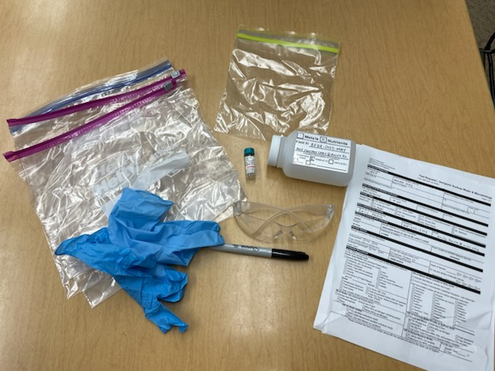
Phosphorus water samples should be collected once per month, for six months from May through October, unless directed otherwise. Each sample should be collected approximately 30 days apart, with no samples collected within 15 days of one another. Do not modify your sample schedule based on storm events unless your sample site has become unsafe.

Equipment
The following equipment is required for each site where monitoring takes place. All equipment is provided to volunteers free of charge, except writing utensils, water shoes, and ice cubes.
    - 250 mL sample bottle
    - 1.0 mL vial of sulfuric acid (H2SO4)
    - Nitrile or latex gloves
    - Safety glasses
Figure 1 Equipment needed for nutrient monitoring
    - Waterproof pen, marker, or pencil (pen is preferred by WSLH for filling out lab slips)
    - Labslips (also called “Test Request – Inorganic Surface Water & Microbiology” form) (one labslip for each sampling site per visit; each lab slip is unique and should never be photocopied)
    - Cooler(s) (one for every 2-3 samples)
    - Two 1-gallon Ziploc bags filled with ice cubes (not ice packs)
    - One 1-gallon Ziploc bag to put lab slip into, to keep dry during shipping
    - One quart sized Ziploc bag to put sample bottle into
    - Waders or sturdy shoes that can get wet
    - Extension pole (PVC pipe or stick) with rubber bands or tape to use to fasten bottle, if sampling from the shore

Collection method
Collect and mail water samples on a Monday or Tuesday. This ensures carriers will have enough time to deliver samples to the lab before the weekend, so that samples do not sit at the lab unrefrigerated over the weekend.
- On a 250 mL sample bottle, check the box next to “Nutrients,” and check the “H2SO4 (0.1%)” box. On the lines next to Field ID, write the provided “Field Number” and the “Sample Address or Location Description” from your lab slip (Figure 2).
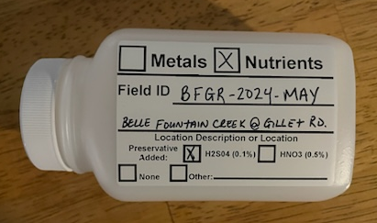
Figure 2 Example of a filled-out sample bottle
- Locate a sampling location that is at least 10 to 20 feet upstream from a bridge crossing (if applicable), in the middle of the stream channel where flow is present. If the waterbody is too deep to enter, or conditions are in any way unsafe, fasten the bottle to an extension pole and use that to collect stream water that is well mixed. Contact WAV staff if you require an extension pole. Enter the stream and walk upstream towards the sampling location. This ensures the sample is not contaminated by sediment that has been dislodged from the substrate.
- In some instances, the water depth may be very shallow. If there are low flow conditions, please contact WAV staff to request advice. It is important to ensure samples are not contaminated with bottom sediment.
- Facing upstream, rinse the 250 mL polyethylene bottle three times with water 3 to 6 inches below the water’s surface. The fourth time, fill the bottle to its shoulder and cap. Be sure not to touch the inside of the bottle or inside of the cap when sampling, as this will contaminate the results. Avoid touching or allowing water at the surface/scum on the surface to touch the rim of the bottle or inside of the cap. One way to prevent this is to uncap and recap the bottle underwater. If you uncap the bottle above the water’s surface, always place the cap top side down to avoid contamination.

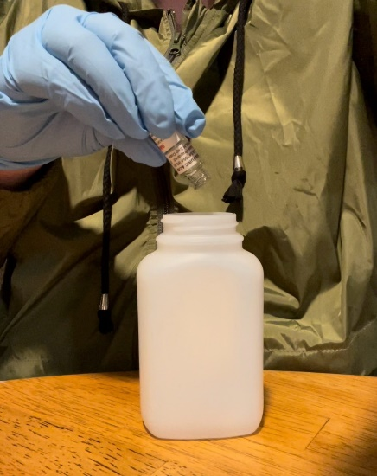
- Wearing gloves and safety glasses, preserve the sample by adding a vial of sulfuric acid to the 250 mL bottle. Back at home, triple rinse the empty vial with water and dispose in the garbage.
Figure 3 Adding acid to the nutrient sample
- Securely cap the bottle and mix the sample by inverting the bottle several times.
- Transport the sample on ice and prepare it to be shipped to the WSLH.

Documentation
A separate lab slip must be submitted with each sample. Lab slips will be provided to you by WAV staff and should never be photocopied. Most of the required fields on the lab slip are automatically filled out for you, but volunteers still need to fill the following fields:
      - Time and Date of Sample Collection, including:
              - Date (mm/dd/yyyy)
              - Time (24-hr clock)
      - Who Collected the Sample, including:
              - Your name (Collected By)
              - Your phone number (Telephone)
              - Your email address (Email)
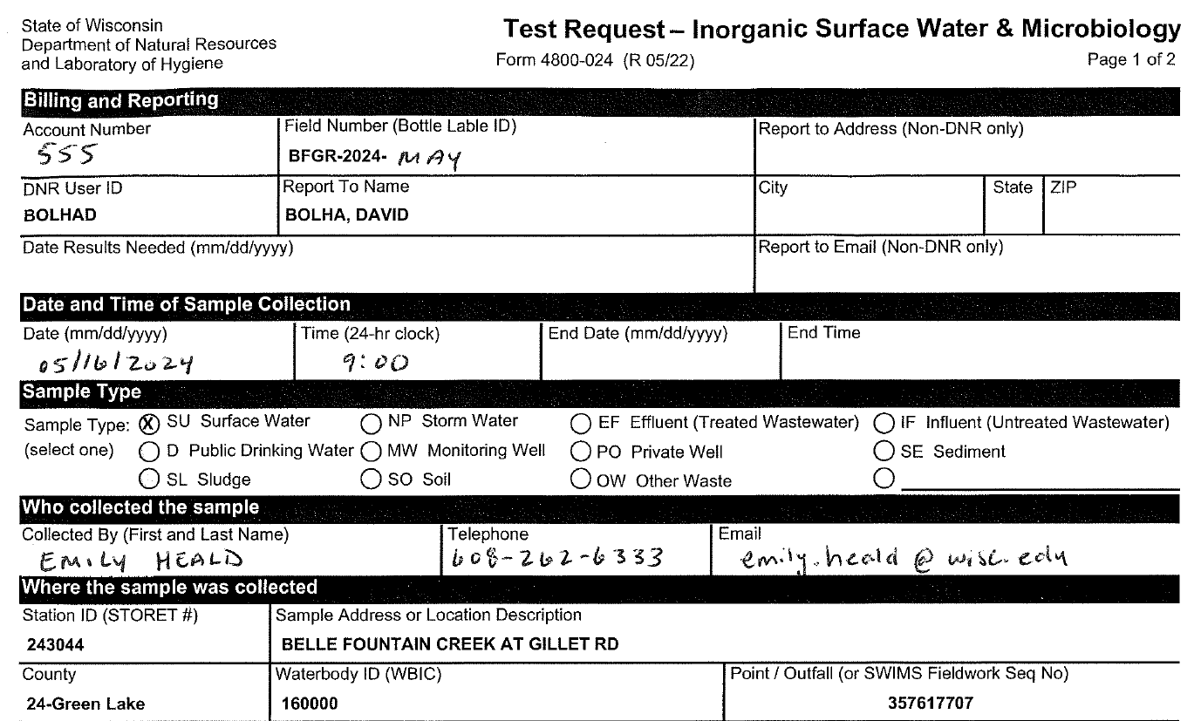
Figure 4 An example of a filled-out labslip

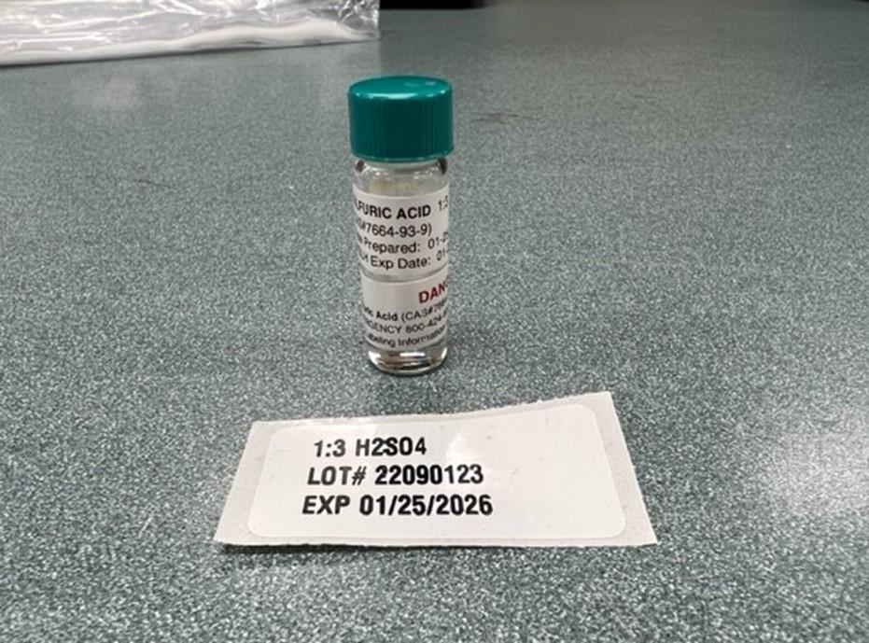
Without the above information on the lab slip, the lab will be unable to process the water sample. This could result in the sample not being tested in a timely manner and therefore being flagged in SWIMS as exceeding the holding time.
Figure 5 Vial of acid with lot information sticker
Acid vials come with a sticker sheet with stickers that indicate lot information and expiration dates. This sticker should be affixed to the bottom of the lab slip sent in with the water sample. If this sticker is not included, your sample risks not being analyzed. Please do not put the sticker over any text on the labslip.

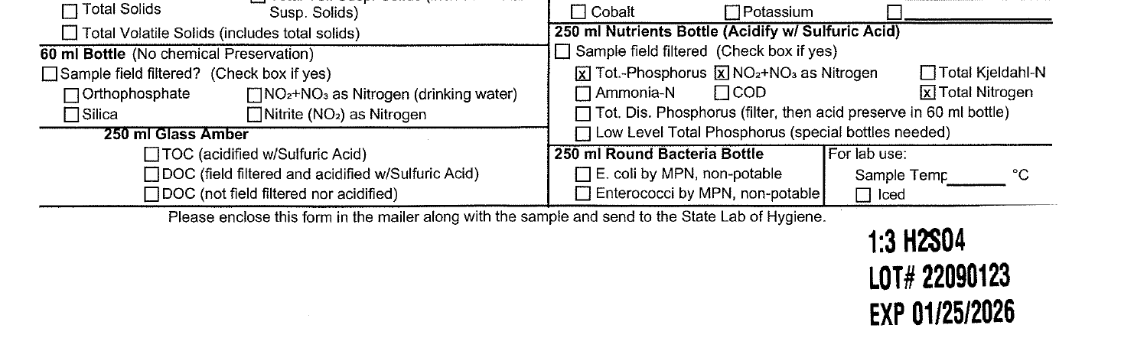
Figure 6 Example of acid lot sticker placed at bottom of labslip

Delivery of Samples to the Wisconsin State Lab of Hygiene
Madison area volunteers should deliver their samples directly to the WSLH (2601 Agriculture Drive Madison, WI 53718) whenever possible. If you are dropping off samples directly to the lab, please see the section below on Dropping Off Samples Directly to the Lab.
Volunteers outside of the Madison area will be sent prepaid USPS shipping labels (one for each month) at the beginning of the sample season, so their samples can be shipped to WSLH after collection.

Equipment
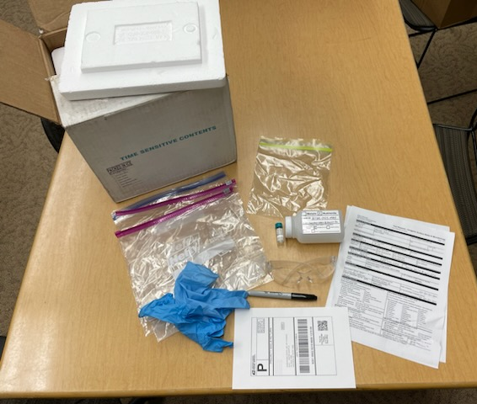
All equipment is provided to volunteers free of charge, except ice cubes and shipping tape.
Figure 7 Equipment needed for shipping nutrient samples
    - 250 mL sample bottle(s) (one per site) containing the collected sample
    - Lab slips (one per site)
    - Shipping cooler(s) that is nestled inside a shipping box
    - Quart Ziploc baggies (one per sample)
    - Two 1- gallon Ziploc bags filled ¾ with ice cubes
    - One 1-gallon Ziploc bag to place the labslip in
    - Ice cubes (not ice packs)
    - Shipping tape
    - Prepaid shipping label

Packing and Shipping Instructions
- Place each sample in a separate quart-size Ziploc bag and securely close. DO NOT place multiple 250 mL bottles in the same bag as you risk cross contamination.
- Fill a 1-gallon size Ziploc bag with ice cubes, about ¾ of the way full. Place the Ziploc bag of ice into the cooler.
- Add the quart Ziploc bag(s) containing the sample(s) on top of that.
- Add a second 1-gallon Ziploc bag of ice, about ¾ of the way full, on top of the samples.
- Double check that the lab slip(s) is/are completed, and then place lab slip(s) in a gallon Ziploc bag and place on top of the bag, or on top of the Styrofoam cooler but within the shipping box.
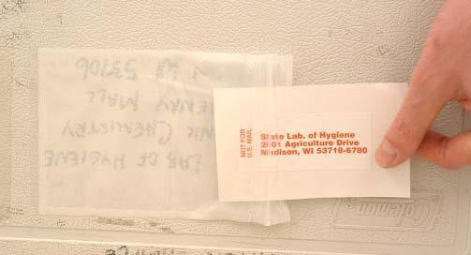
- Close the box lid and wrap with reinforced shipping tape completely around the box.
Figure 8 Mailing label cards on shipping boxes
- Remove the mailing label card from the plastic envelope that comes adhered to your shipping box and flip over so the Wisconsin State Laboratory of Hygiene address is exposed and reinsert into the envelope. Ensure your shipping address is printed on the other side of the mailing card.
- Ship the samples to the WSLH using the United States Postal Service (USPS). Affix the shipping label to your cooler. Then bring the package to the nearest USPS office.

Considerations/ Precautions
Samples should be shipped as soon as possible, within 1-2 days after being collected. Holding times are longer than one week, but the clock begins immediately after sampling and the lab needs them quickly in order to process samples on time. If the weather is extremely warm, if you collect a sample from more than one site, and/or if you collect duplicate samples in addition to your regular sample, you should add extra ice or use multiple shipping coolers to submit your samples to the lab. Refrigerate the samples or keep them on ice until they are shipped. Samples should be shipped on a Monday or Tuesday to ensure the samples arrive to the lab before the weekend. If samples arrive to the lab late in the week or on a weekend, they risk becoming too warm to analyze.

Dropping Off Samples Directly to the Lab
Volunteers in the Madison area are encouraged, but not required, to drop off samples directly at the WSLH. The address for the lab is 2601 Agriculture Drive Madison, WI 53718. Samples and corresponding labslips should be dropped at the loading dock, located in the back of the lab off Vondron Road, as indicated in Figure 9.
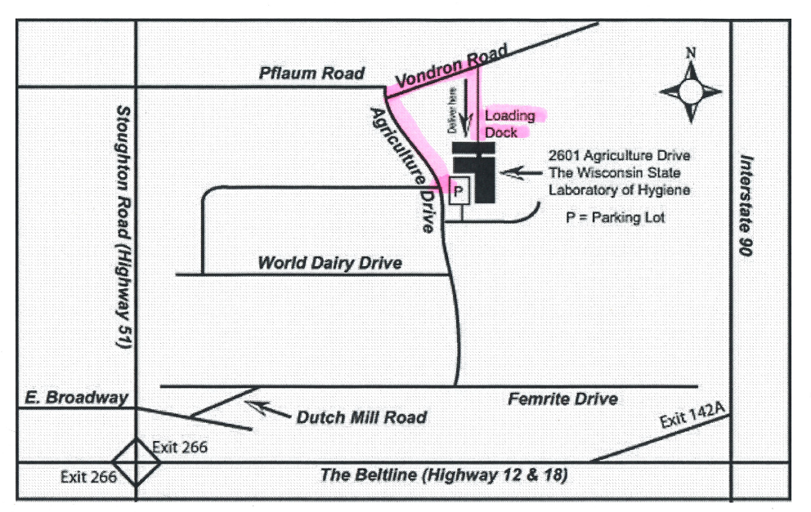
Figure 9 Map depicting sample drop off location at WSLH

Collecting a Duplicate Sample
To ensure quality sample collection of data collected by volunteers, ten percent of total phosphorous samples are randomly selected to have additional testing. The additional tests are called “duplicates,” because essentially, the same sample is collected twice. The two samples are then compared to determine if their test results are similar. If the results are very different, this may indicate improper sample collection.
If your site(s) have been selected at random for duplicate sampling, you will be notified by WAV staff. To carry out sampling, please read the following instructions.
The result of this additional sampling is that you will be mailing a total of two water samples to the lab following one of your site visits: one regular sample and one duplicate. Each sample should be placed in a separate quart-sized Ziploc bag. Refrigerate or ice the samples until you are ready to ship, ideally within 1-2 days, like with your regular sample.

Equipment

- 250 mL polyethylene bottle
- 1.0 mL vial of sulfuric acid (H2SO4)
- Nitrile or latex gloves and safety glasses
- Waterproof pen or marker, or pencil (pen preferred by WSLH)
- Lab slip marked as “duplicate”
- Cooler with ice (from regular sampling)
- Waders or shoes that can get wet (not needed if sampling is done from shore)

Collection Method
Please prepare this sample at the same time as your regular sample, as follows:
Collect, preserve, and ship a second sample from the same location following the directions starting on page 4 of this manual. Find the lab slip that is pre-marked “DUPLICATE” near the middle of the page, fill in the required fields, and place it in the Ziploc bag with the original lab slip. Be sure to write the correct bottle ID on the bottle, which should include “DUP” at the end of the Field ID, as indicated on the duplicate labslip. Remove the sticker with the acid expiration date from the sheets of acid stickers and affix it to the bottom of the lab slip.
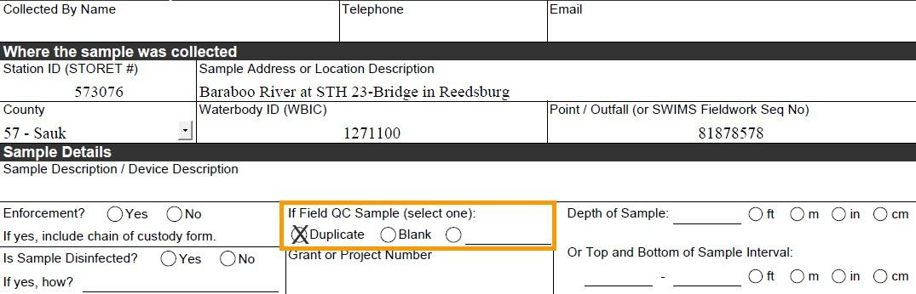
Figure 10 Example of a labslip for duplicate samples

Equipment Cleaning Procedures
Help prevent the spread of aquatic invasive species in our streams and rivers!

Anytime you monitor, even if just at one stream site
BEFORE leaving the stream:
- INSPECT equipment and REMOVE sediments, plants and animals
- SCRUB equipment with a stiff brush (including crevices) to remove sediment and debris
- RINSE equipment with tap water (using a spray bottle is useful for this)
- DRAIN all water from equipment

Additional cleaning information can be found on the DNR’s website.

ADDITIONAL RECOMMENDATIONS:
- If you visit more than one site, we recommend cleaning your gear with a bleach solution as described on the DNR’s website.
- Do not use felt-soled boots. They are more likely to harbor small-bodied AIS and are very difficult to disinfect completely.
- If visiting multiple sites along the length of a stream or river, begin at the top of the watershed and work downstream.

