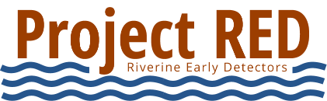
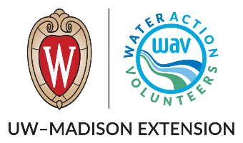

Project Riverine Early Detectors (RED) Volunteer Job Description

Position: In-Water Monitor (paddling, angling, or wading)
Purpose
Help detect aquatic invasive species (AIS) by observing rivers while paddling, fishing, or wading. Covers a broader area by moving through the river channel.

Key Responsibilities
- Monitor for invasive species while recreating on or in the water
- Observe aquatic plants and animals across a section of river
- Document and report suspected invasive species and/or absence of species
- Follow safety, observation, and reporting protocols outlined in the Volunteer Monitoring Manual
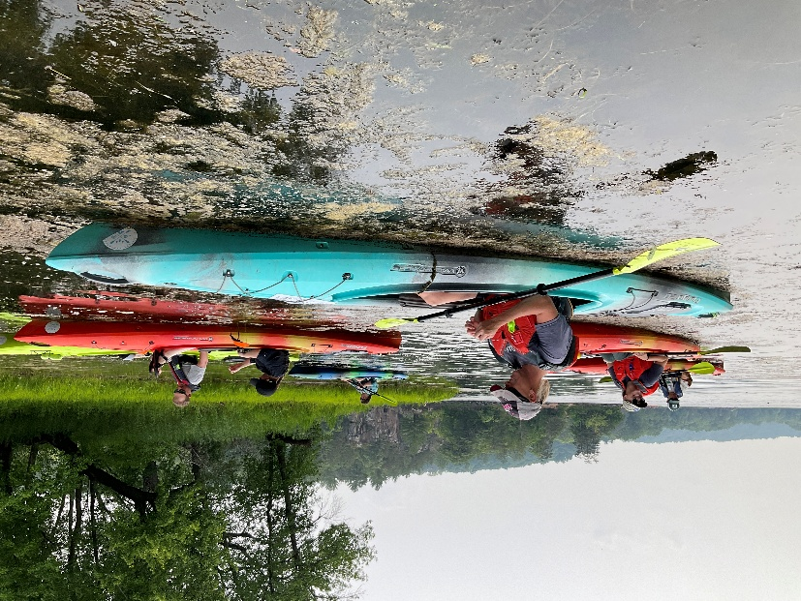
Time Commitment
Flexible; typically 1–3 hours per outing, integrated into recreational time
Volunteers in kayaks search for AIS on a river

Skills/Interests
- Comfortable paddling, fishing, or wading in rivers
- Enjoys being outdoors and on the water
- Observant and attentive to detail
- Interest in conservation and protecting waterways

Training & Support
- Training provided through attending an in-person training or by Project RED digital resources
- Detailed monitoring, identification, and reporting guidance available in the Volunteer Manual
- Support from local AIS coordinators and Water Action Volunteers program staff

