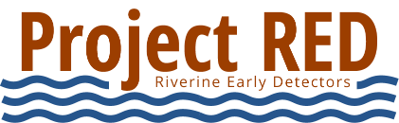
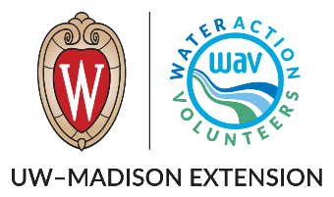

Project Riverine Early Detectors (RED) Volunteer Job Description

Position: Shoreline Monitor
Purpose
Help detect aquatic invasive species (AIS) by surveying riverbanks and nearshore areas, contributing valuable observations from accessible shoreline locations. Provides focused observation of nearshore and access-point areas.

Key Responsibilities
- Walk designated or self-selected shoreline areas to look for invasive species
- Observe shoreline vegetation, shallow water, and visible aquatic life
- Document and report suspected invasive species and/or absence of species
- Follow safety, observation, and reporting protocols outlined in the Volunteer Monitoring Manual
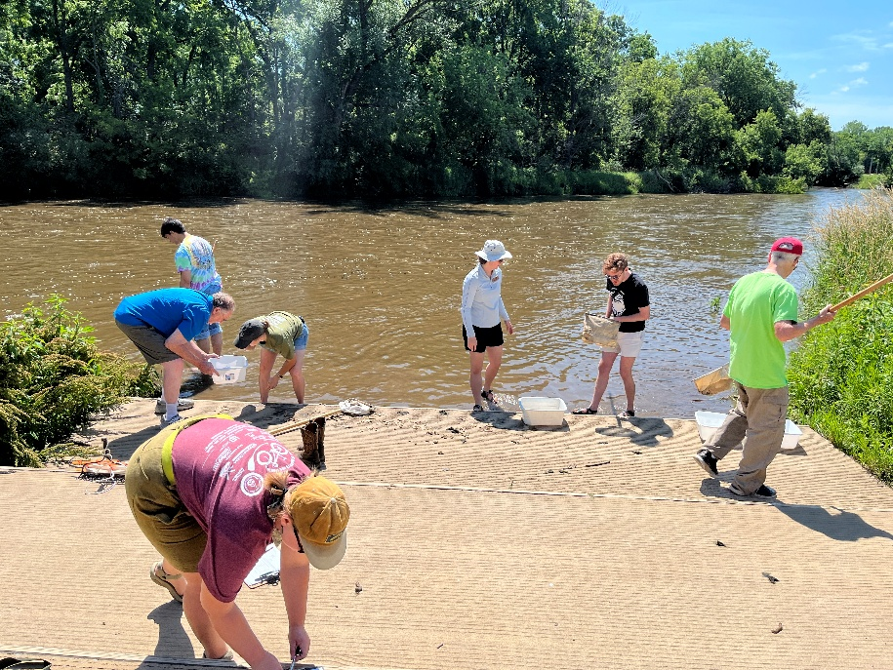
Time Commitment
Flexible; typically 1–2 hours per outing
Volunteers search for AIS at a river boat landing

Skills/Interests
- Comfortable walking on uneven or natural terrain
- Enjoys exploring riverbanks and natural areas
- Observant and detail-oriented
- Interest in conservation and protecting waterways

Training & Support
- Training provided through attending an in-person training or by Project RED digital resources
- Step-by-step monitoring, identification, and reporting guidance available in the Volunteer Manual
- Support from local AIS coordinators and Water Action Volunteers program staff

